**Practice april**

№1. IT professionals.

1. Hardware engineer

2. Software engineer

3. Blog administrator

4. DTP operator

5. Network administrator

6. Webmaster

7. Computer security specialist

8. Help desk technician

№2. Job advertisements

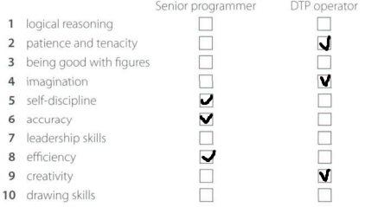

C. Since Charles spent the most of his time working in graphical design and page layout, I think DTP operator appears more suitable for him.

№3. A letter of application

A.

1. Senior programmer

2. She saw an ad in The Times

3. She has been working as a software engineer for the last three years

4. She wrote four programs in COBOL for commercial use and C for the major retail chains

5. Two years ago

B.

1. Until

2. For

3. Since

4. Ago

№5. Language work: the present perfect

A.

1. ‘s never liked

2. ‘ve been working

3. ‘s been using

4. have you written

5. ‘s been writing

6. ‘ve interviewed

B.

1. ‘s been

2. worked

3. Have you ever worked

4. ‘ve lost

5. sent

C.

1. Have you ever lived or worked in another country?

2. Have you ever had a bad job interview?

3. Have you ever done a job you hated?

4. How long have you been studying English?

5. How long have you been using computers?

6. How many emails have you received today?

7. How many jobs have you applied for this year?